ADJECTIVES TO DESCRIBE INVENTIONS & DEVICES

New, modern, important, useful = handy, scientific, technological, technical, recent, greatest, wonderful, ingenious, latest, time-saving, labour-saving, practical, valuable, cultural, industrial, remarkable, successful, electrical, fantastic, marvelous, minor, brilliant, clever, witty, notable, creative, patented, innovative = novel, curious, unique, beneficial, obsolete, groundbreaking = revolutionary, low/high-tech, wacky = odd

**1. Choose some of the adjectives above to describe these inventions:**

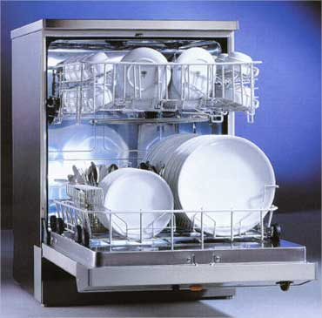

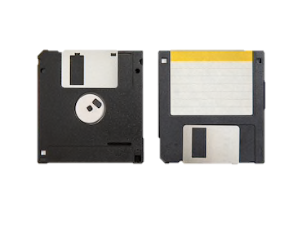

º

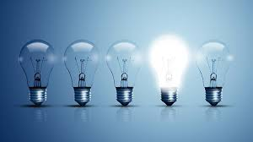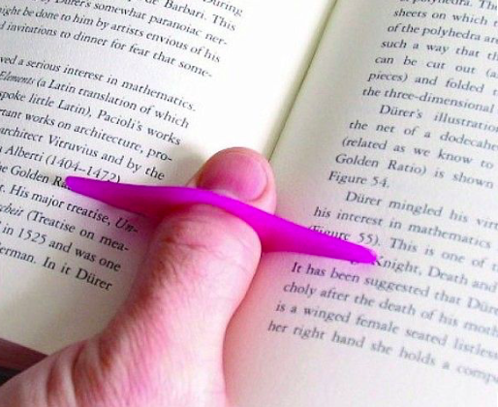

WORD FORMATION

**1. Complete each phrase using a form of the word in bold.**

1. a great ______achievement______ **achieve**
2. highly ________beneficial____ **benefit**
3. a _______creative_____ person **create**
4. a recent __development__________ **develop**
5. an important ______discovery______ **discover**
6. a major ________improvement____ in something **improve**
7. a useful ______invention______ **invent**
8. bring out a new ____product________ **produce**
9. a ________scientific____ fact **science**
10. a _______soluton_____ to a problem **solve**
11. a huge ____medical________ breakthrough **medicine**

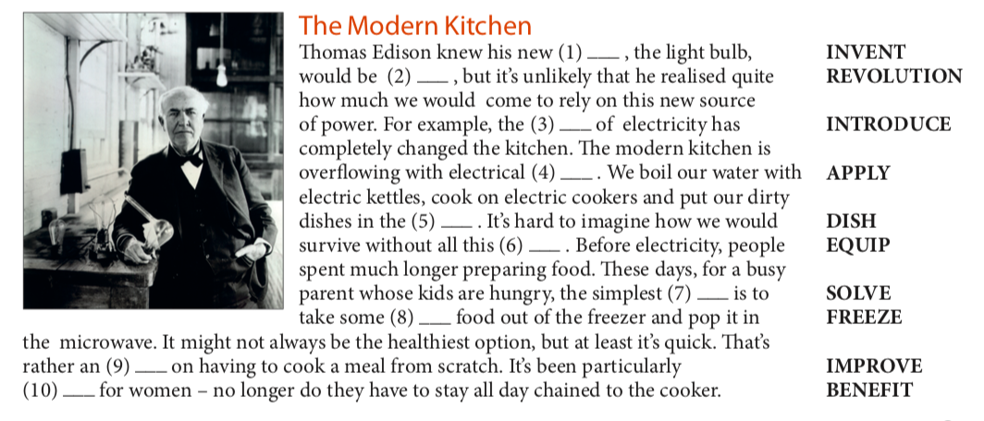**2. Complete the text using a form of the word in bold.**

**FORMATION**

PHRASAL VERBS

**Use the correct form of these phrasal verbs about technology to complete the sentences.**

break down · come on · come up with · cut off · get through · look into · put in

1 If you _____put in_______ an appliance like a washing machine, you install it.

2 If you ___come up with_________ a new idea for a product, you have an idea.

3 If you ______look into_____ a new development, you investigate it.

4 If a car _____breaks down_ , it stops working.

5 If your electricity is _____cut off____ , it is disconnected.

6 If you can’t ___get through_ to someone on the phone, you can’t connect to them.

7 If something has ____come on__ , it has developed or improved.

**Say which of the two statements below you agree with most, giving reasons. Consider the use of technology in some of these tasks:**

shopping **·** solving mathematical problems **·** writing essays **·** doing housework  
learning languages **·** making music **·** finding information **·** communication

1. I'm totally **in favour of** technology. Computers and labour-saving devices can help us do things more quickly – leaving us free to do more important things. Intelligent devices and things like smartphones are the future.
2. The more we let technology interfere in our lives, the more we move away from a natural existence. Technology and computers can help us do nearly everything but it is not always a good thing. We need to learn to do things, and to think, for ourselves.

|  |  |  |
| --- | --- | --- |
| BENEFITS | NEGATIVE ASPECTS | EXAMPLE |
| It helps us communicate |  | If stuck in traffic – can call on your mobile |
|  | Technology makes us lazy | Many people can’t do simple maths – always use a calculator |
|  |  |  |
|  |  |  |
|  |  |  |
|  |  |  |

SPEAKING

1- hacking

2- writting the code

3- high school

4- 2 days

5- sleeping bags

6- experience

7- four

8- team-building season

9- 300

10- free of charge